Introduction to network traffic monitoring and Network Logs
Introduction
Earlier in the course, you learned there are many different protocols, and some are better than others when it comes to security. You have also learned how you can view these protocols from a Windows or MAC PC, but that gives you a very limited view. That's because it only shows you what is going on on your machine at the time when you run the netstat-a command, which doesn't tell you if there's anything else on your network that shouldn't be there. That's where monitoring comes in.
Monitoring can be split into two main tasks: network monitoring and network traffic monitoring. On the one hand, network monitoring involves keeping track of network devices for availability and faults. In contrast, network traffic monitoring is monitoring what protocols and data are moving around a network and monitoring for performance and security threats.
Now that the office and shop are connected to the internet, it's critical for Sam's Scoops to monitor their network properly, but how do they keep track of everything that's happening on the network, and not just on individual computers? The answer is network traffic monitoring, the topic of this reading. In this reading, you will learn about what can be monitored and what components and protocols are needed to perform the important task of network traffic monitoring.
Monitoring bandwidth
Bandwidth is an important concept when it comes to network traffic monitoring and performance. It's a term you might be familiar with because when you look for an internet provider, you generally want the fastest connection you can afford, meaning bandwidth is your first priority. That's because it determines the rate at which data moves across a network. This is not usually a problem if only a few people and applications use a network. But things can get pretty busy, and some applications are more demanding than others. Just take video conferencing as an example; it takes up a lot more bandwidth than just visiting a web page. Bandwidth is much like the road in the illustration below: you can only accommodate a certain number of cars before the road becomes blocked. That's why monitoring what is using a lot of bandwidth is critical.

Monitoring users
When monitoring your network, you also want to track users to check what applications they use and what their regular day-to-day activity is. Doing this can create an audit trail, but more importantly, it reveals patterns so you can better understand the network traffic behavior on a day-to-day basis. Knowing how your network behaves makes it easier to spot when something isn't quite right. This is very similar to a security guard keeping an eye on a shop and identifying suspicious customers based on what they've learned from the out-of-the-ordinary behavior of customers who previously stole from the shop. On a network, you can also look for out-of-place activity. For example, you notice a new application for the first time or that something specific uses a lot more bandwidth than usual. This could be a security problem, maybe there's an attack generating traffic, or perhaps it's simply something new that needs more bandwidth, and the network has to adjust to accommodate it.
Network traffic monitoring steps
Network monitoring can be separated into three steps; Step 1 is choosing the correct data source. Step 2 involves analyzing the correct component in a network. And Step 3 is about using a monitoring tool to optimize and display data in a readable format. Let's examine the steps.
Step 1: Choosing your data source and protocols
To monitor network traffic, you need to determine the best source. This monitoring can be split into two categories: packet capture and flow analysis.
Packet capturing
This is a way of collecting copies of packets that are moving around a network. You can decide to do this at different points across the network using a computer to run the packet capture software and a mirrored port. A mirrored port is created to copy any data that runs through it to your computer port and the connected packet capturing software. An application called Wireshark has traditionally been the go-to choice for performing this activity.
Flow analysis
Flow analysis is supported on many network devices and is typically a built-in feature. Two protocols that can do this are called Netflow and Sflow. Netflow is a Cisco proprietary protocol that runs on Cisco routers and switches. SFlow was developed to work on many platforms. Netflow collects IP traffic only, but SFlow can collect and analyze data from layers 2 to 7 of the OSI model. This type of analysis does not copy data from one port to another, so it's very flexible as the data can be collected centrally.
Step 2: Selecting the correct component
Devices on the network that can support traffic monitoring include servers, switches, routers, and firewalls. You can even monitor specific interfaces and their applications as well as devices. However, you don't want to capture everything happening everywhere on your network, as this will generate a lot of data to analyze. You need to pick key areas of the network that oversee communication. On Sam's network, the central router would be the best place as traffic flows to and from that device.
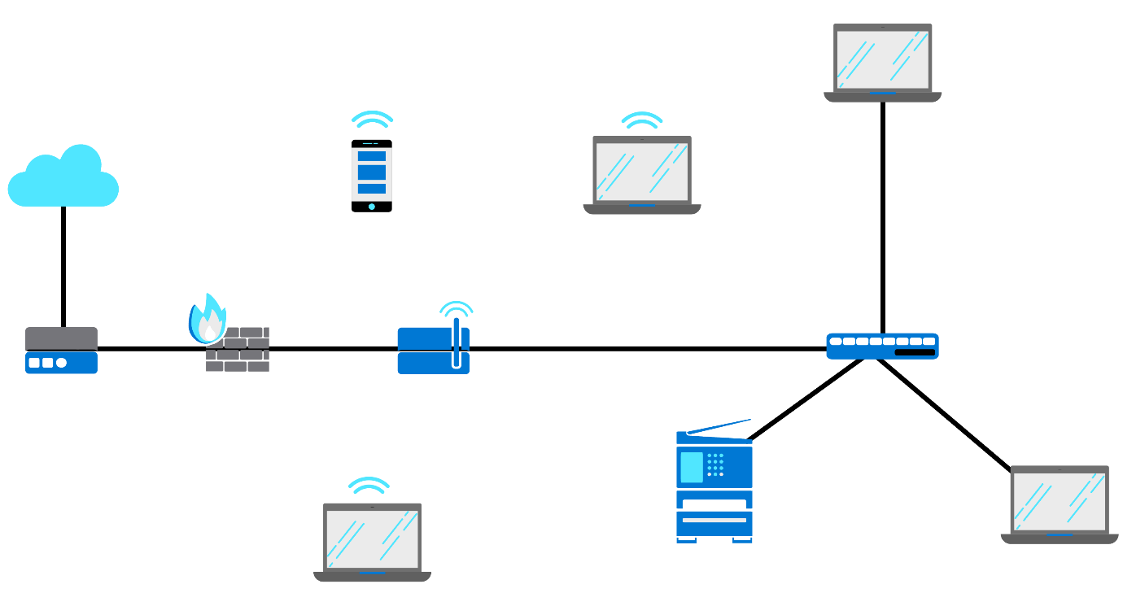
Sam's network at this stage is quite simple, so monitoring traffic with either packet capturing or flow analysis would be okay. But as it grows, packet capturing will only be used when troubleshooting particular problems in a specific area because it's restricted to the area you are plugged into. Flow analysis does not capture whole data packets like packet capturing. Instead it captures packet details like ports and IP addresses. In other words, just the information needed to understand data from many different devices at the same time.
Step 3: Using monitoring tools
When a network grows, so does the amount of data flow that you will need to analyze, and this is when you need third-party software that can collect all the flow traffic. There are many different traffic monitoring tools out there that are very capable of analyzing flows and putting the data into an easy-to-read format. They usually also include tools for alerting a network manager of problems or anomalies on the network.
Conclusion
Network traffic monitoring can help you to understand how a network and applications are performing and use that data to make sure that the bandwidth and network are not overwhelmed. This is an important step that Sam needs to take to keep the network secure and functional. By monitoring network traffic, a business like Sam's Scoops can quickly detect and respond to security incidents, prevent data breaches, and ensure that network resources are used efficiently.
Network logs
Introduction
By now, you know that information can be collected from a network in different ways. For example, packet capture and flow analysis are two ways of monitoring a network. These give you a real-time idea of how data flows in a network. There are many data points, but this information shouldn't just be monitored; it should also be recorded. And in this reading, you're going to explore how information from data points is recorded in network logs, what kind of different types of logs there are, and how you can search and filter logs.
What is a log file?
Log files are records of events committed to a file in a list format. They can include all sorts of information about events that happened at a particular time. Every device on the network creates log files, thus giving you a history of what's been happening.
Logs typically contain five headed-up areas. They are:
- Timestamp –the time of the event.
- Log level – how severe or important the event is.
- Username– who caused the event.
- Service or application – what caused the event.
- Event description – what has happened.
Below is an extract from a Windows machine log, telling you that a logoff event occurred.
In this example, you'll notice, from left to right:
- The date and time the event happened.
- The user information under the heading "Source".
- The Event ID number.
- The event under the heading "Task category" where the logoff is specified.
This information is useful, especially because it's timestamped. If you were troubleshooting a problem, you could check the logs of a particular device to see what was going on at the time of the issue. Log files can be huge and store a lot of information, so you need to know what you are looking for. Thus the importance of the timestamp is a critical part of any log.
Let's examine a few examples of different log file types.
Log file types
- Event log –records information about the usage of network traffic and tracks login attempts, application events, and failed password attempts.
- System log (or syslog) – records operating system events, including startup messages, system changes, shutdowns, and errors and warnings.
Below is an example of a system log from a Windows PC event viewer, showing the level of the log, the date and time, source, event ID, and task category.
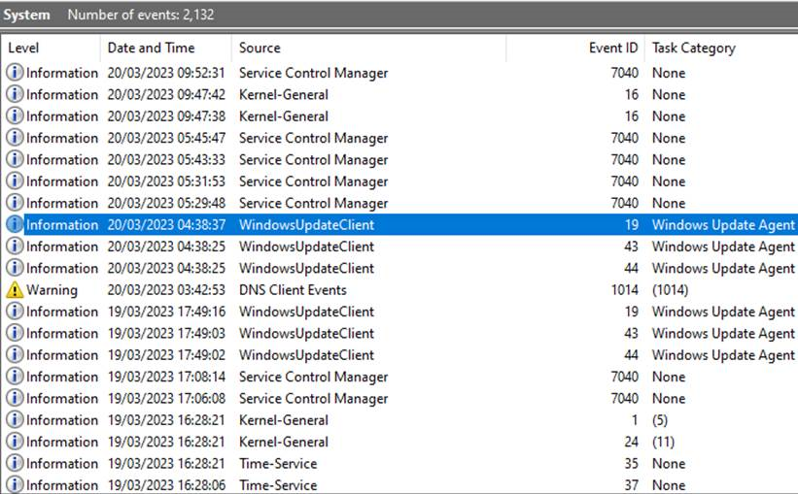
- Server log – contains a record of activities in a text document related to a specific server over a specific period of time.
- Change log – lists changes made to an application or file.
- Availability log –tracks uptime, availability, and system performance.
- Authorization and access log – lists who is accessing applications or files.
- Resource log –provides information on connectivity issues and any capacity problems.
Logs can be stored in many different formats. Applications like the Windows event viewer allow for easier troubleshooting and viewing of different events. But not all devices on a network have a graphical application like the event viewer on a Windows PC. Many logs are simple text files like the one below that shows a large amount of log information without the clearly defined categories of the event viewer. Sure, you can find information in such a file, but this is just one log from one device, and that's a lot of information to sift through.
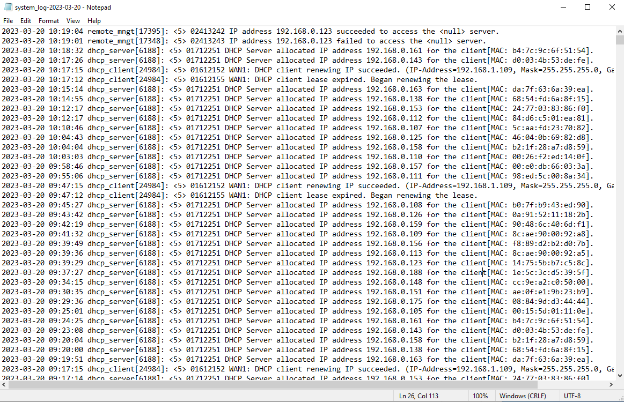
Log file filtering
Filtering and searching through log files can be tedious and time-consuming, so it's good to know that the process can be sped up. Here are three ways of searching log files.
The easiest is to have a tool that can capture, display, and even analyze logs for you. Like, for example, Windows Azure Monitor, which you can use in the cloud to track what is happening. In the example below, an Azure Monitor screen provides an alphabetically-arranged list of queries, and it tells you the number of requests and calls by APIs, among other information.
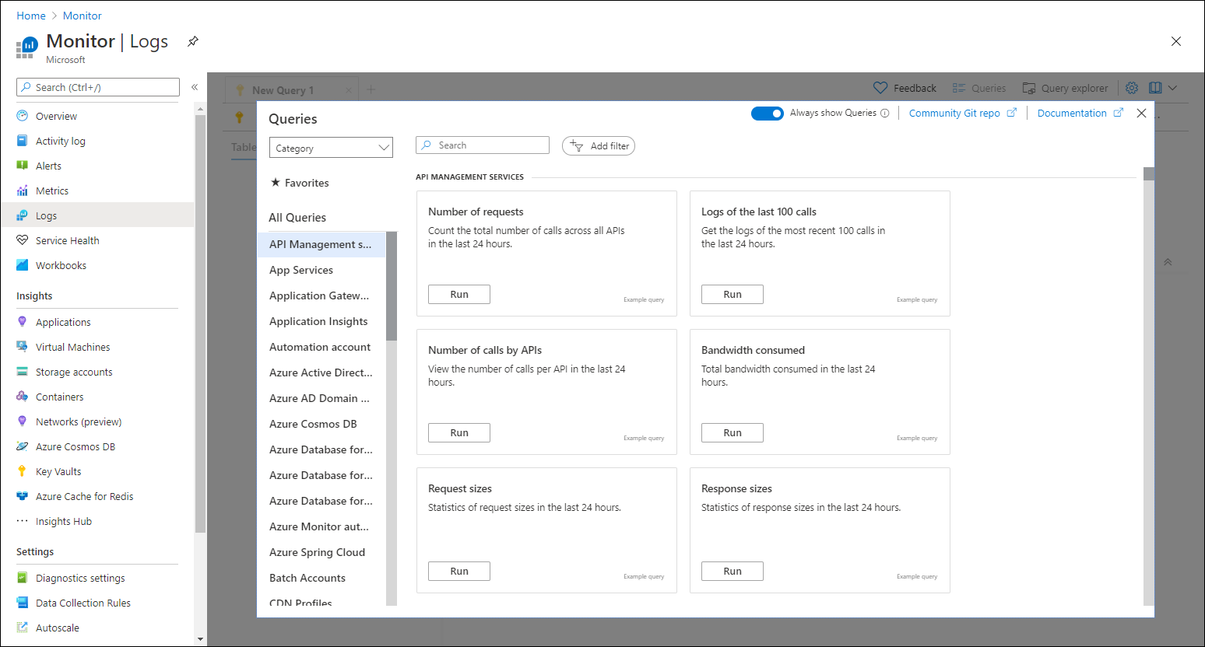
The next option would be to use a search function within an application like Notepad in Windows, like in the example below. This is very handy because it has a find option, but you do need to know what you are looking for in the first place to use this function.
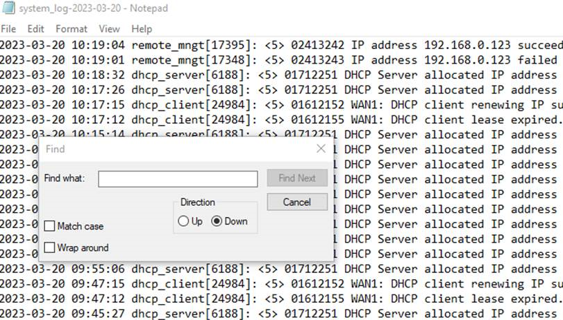
Lastly, you can use search and filter commands. Different operating systems will allow you to search log files using certain commands. For example, the command grep is a great command as it is supported across many Linux systems and will allow you to search for patterns within log files. If you're searching for a particular error or IP address, this can be a very powerful command. Using such a command requires practice for you to really benefit from the advanced search capabilities and filtering they can provide. Here is a resource, How to use the Linux grep command, that can help get you started.
For Windows, findstr is the command to use in the command prompt application. Examples of using this command can be found in this Microsoft Learn resource about findstr.
Windows PowerShell is another powerful tool used to filter and search using the Select-String command. In the example below, Select-String was used to search for events related to the IP address 192.168.0.111, and PowerShell provided a list.
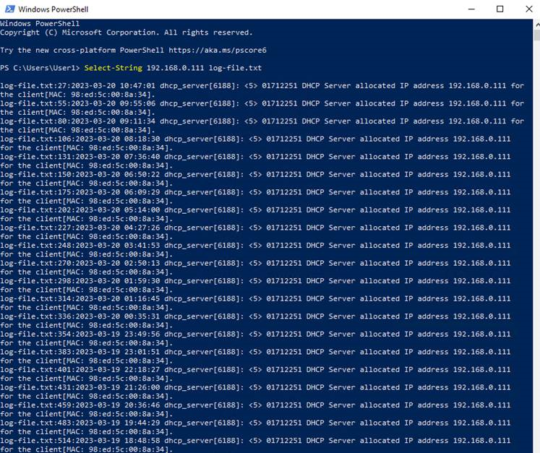
If you want to examine some more examples you can use this Microsoft Learn resource about Select-String.
Conclusion
There are many sources of information across the network, and even a small network like Sam's Scoops has a lot of data because every device is actively producing data. This data is split into different types of log files, like events in an operating system or a log of who is accessing a device. Everything is tracked, which means that if there is a problem, a log file exists to give you a clue as to what might have gone wrong. While it's great that everything is tracked, it also means that you have a large volume of data to work with. Luckily, there are tools available to filter and search the data. Using purpose-built applications that do the work for you is a great choice, but if you are dealing with a small network like Sam's, then using search facilities within an application like Notepad, or commands that can perform the filtering for you is a great choice.

